Date 28.11.2019

**LGBT Analysis Report**

* **Objectives:**

Analyzing the data using R technology trying to find insights to support the development of more effective laws and policies to fight discrimination, violence and harassment, improving equal treatment across society

* + - * **Dataset Description:**

Data is about a survey asked to lesbian, gay, bisexual and transgender (LGBT) people whether they had experienced discrimination, violence, verbal abuse or hate speech on the grounds of their sexual orientation or gender identity. The results reflect the experiences of more than 93,000 individuals who completed the online survey across Europe.

* + - * **Features Titles**:
        + CountryCode, subset, question_code, question_label, answer, percentage, notes.
      * **Data Preprocessing:**

Dataset has no null values.

Note column is the only column has many null values column begin dropped

* **Examples of analysis questions:**

**Which is the most country has support the daily life for LGBT community?**

Below graph is represent five questions, answer and percentage with ball colors were ask to participations in order to check how is their daily life questions are:

when you looking for the job do you felt any discrimination

when you in work environment do you felt any discrimination

when you looking for the apartment do you felt any discrimination

when you in the university or college do you felt any discrimination

when you requested social service, from social personal do you felt any discrimination



**Which the most subset where has the most difficulties accessing the healthcare services among all subsets?**

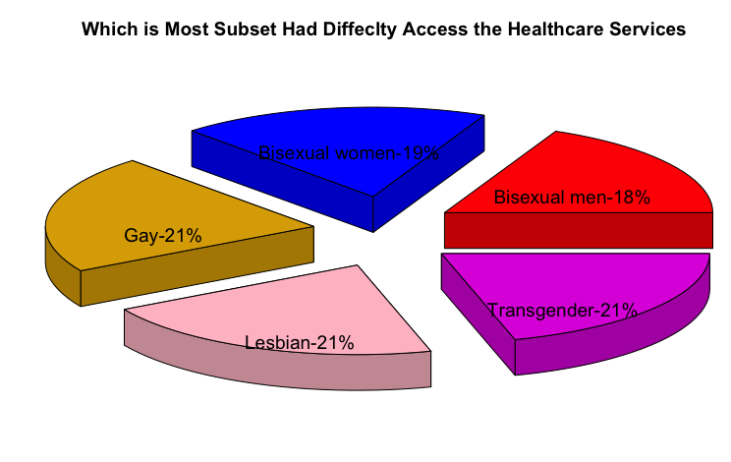

* **Conclusion:**

The Most LGBT friendly country is Czech Republic

Transgender sample is bit higher however, they are not the most felt discriminated when it comes to healthcare service access was equally difficult for Lesbian, Gay too with all 21% each.

Czech Republic, Finland and Ireland are countries which where most the sexual attack, or threat of violence happens at Homes.

sexual in public and home for both Ireland and Finland are both higher however Czech Republic is almost the same

Latvia is having the lowest sexual attack, or threat of violence domestically and the highest when it comes to public

60 to 80% of LGBT are avoid begin open about themselves specially in public transportation